M.N. Hamas
s92068805 | s92068805@ousl.lk
Course: EEX5362 – Performance Modelling
Open University of Sri Lanka, Nawala
Performance Modeling and Evaluation of a Hospital Outpatient Registration Queue

Contents
1. System Description and Performance Goals 2
2. Modeling Approach and Assumptions 2
3. Data Description and Methodology 3
Methodology: 3
4. Detailed Analysis and Findings 3
5. Visualizations 4
6. Limitations and Future Extensions 6
This study has several limitations: 6
Future extensions could include: 6
7. References 6
8. Appendix 6

1. System Description and Performance Goals
This mini project studies the performance of a hospital outpatient registration system. In many hospitals, patients must complete registration before accessing medical services. During busy clinic hours, patients arrive close together, which may lead to long queues and increased waiting times. Efficient registration is important because delays at this stage can negatively affect the entire patient experience.
The selected system consists of a single waiting queue served by two registration counters. Patients arrive randomly during a clinic session, and each patient requires a different amount of time to complete registration. This makes the system suitable for performance modeling, as it includes variable arrivals, limited service resources, and queue formation.
The main performance goals of this study are:
- To minimize patient waiting time at registration
- To measure throughput, defined as patients registered per hour
- To identify bottlenecks during peak arrival periods
- To evaluate utilization of registration counters
- To test improvement strategies such as adding counters or reducing service time

2. Modeling Approach and Assumptions
A Discrete-Event Simulation (DES) approach is used to model the registration system. DES is suitable because system behavior changes at discrete points in time, such as patient arrivals, service start, and service completion. The simulation allows the system to be tested under different conditions without disturbing real hospital operations.
The following assumptions are made:
- Patients are served on a First-Come-First-Served (FCFS) basis
- Only the registration stage is modeled
- Service times are taken directly from the dataset
- Counters are always available during the clinic session
- Patient behavior such as leaving the queue early is not considered
These assumptions keep the model simple while still capturing key performance characteristics.

3. Data Description and Methodology
The analysis uses a simulated dataset of 50 patients, representing a four-hour outpatient clinic session. Real hospital data is difficult to access; therefore, realistic simulated data is used for academic modeling purposes.
The dataset includes:
- Patient ID
- Arrival time (minutes from clinic opening)
- Service time (minutes required for registration)

Methodology:
- Load the dataset from a CSV file
- Build a DES model using SimPy in Python
- Run the simulation under different scenarios
- Measure performance metrics such as waiting time, queue length, throughput, and utilization
- Compare results to identify inefficiencies and improvements

4. Detailed Analysis and Findings
Four scenarios were evaluated:
- Scenario A: 2 counters (baseline)
- Scenario B: 1 counter
- Scenario C: 3 counters
- Scenario D: 2 counters with 10% faster service
In the baseline scenario, the system performs reasonably under moderate load, but waiting time increases when arrivals occur close together. When only one counter is used, waiting time and queue length increase significantly, showing that the system becomes overloaded. This confirms that insufficient service capacity is a major bottleneck.
Adding a third counter reduces waiting time and queue length, while improving throughput. Counter utilization becomes healthier, meaning counters are busy but not overloaded. Improving service speed without adding staff also improves performance, though capacity limitations can still appear during heavy arrival bursts.

5. Visualizations
The following figures illustrate the performance comparison between scenarios.
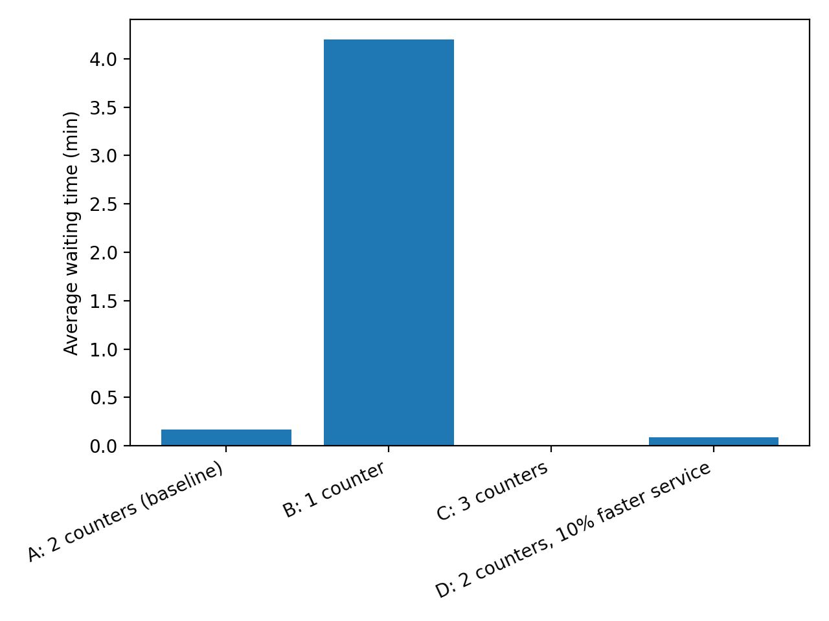Figure 1: Average Waiting Time by Scenario
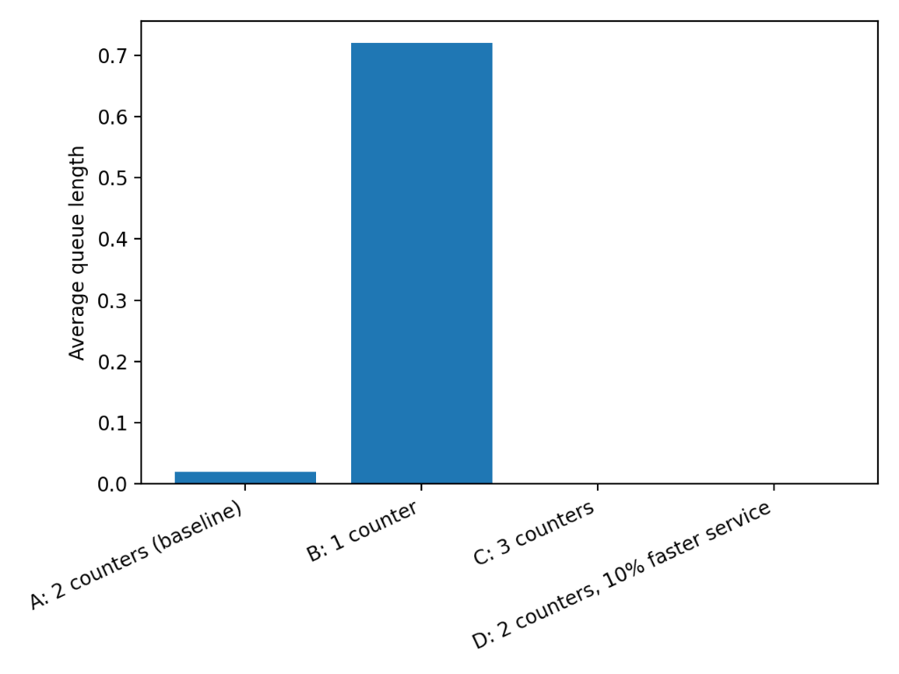
Figure 2: Average Queue Length by Scenario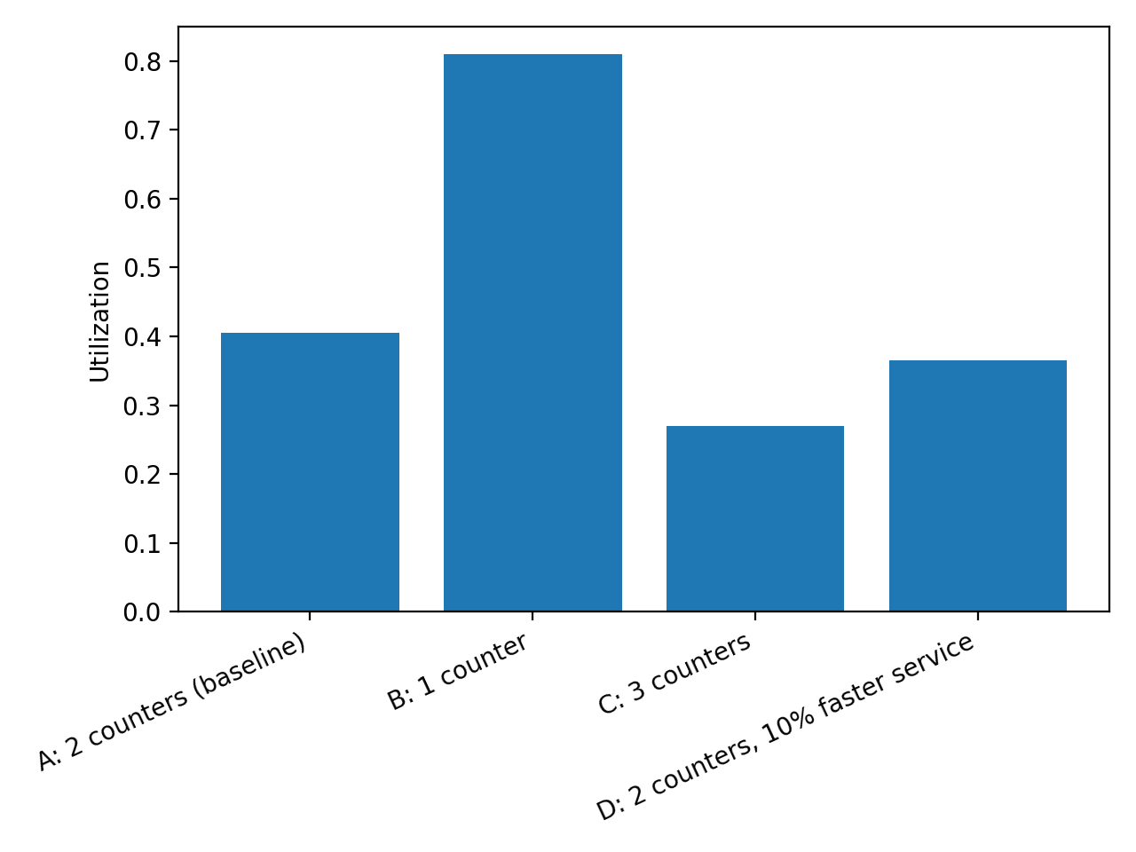
Figure 3: Counter Utilization by Scenario
These visualizations clearly show how capacity and service speed affect system performance.

6. Limitations and Future Extensions

This study has several limitations:
- The dataset is simulated and may not represent a specific hospital exactly
- Only one stage of the patient journey is modeled
- No patient priority rules are included

Future extensions could include:
- Modeling additional stages such as triage and doctor consultation
- Introducing priority queues for elderly or urgent patients
- Using real hospital timestamp data for validation

7. References
- Banks, J., Carson, J.S., Nelson, B.L. and Nicol, D.M. (2010) Discrete-Event System Simulation. 5th edn. Upper Saddle River: Pearson.
- Law, A.M. (2015) Simulation Modeling and Analysis. 5th edn. New York: McGraw-Hill Education.
- Data Set: https://github.com/hamasnooman/EEX5362_MP_S92068805/blob/main/50_Patient_Dataset.csv

8. Appendix

